Response time analysis
The platform developed during this project may be used to develop a real-time application. In order to validate the platform a fictive application will be described, analysed and then used to validate the platform (time permitting).

The platform works with sporadic and periodic threads, as well as timers and mutexes (critical regions). It uses pre-emptive fixed priority scheduling and priority inheritance via the immediate ceiling priority protocol. These subjects have been discussed elsewhere in the report and will not be further elaborated here.

Experimental test application
The experimental test application takes its basis in the set-up from Burns & Wellings figure 1.1, page 4. The set-up is elaborated with a sporadic task in the form of an on/off-button. This is shown in Figure 1.
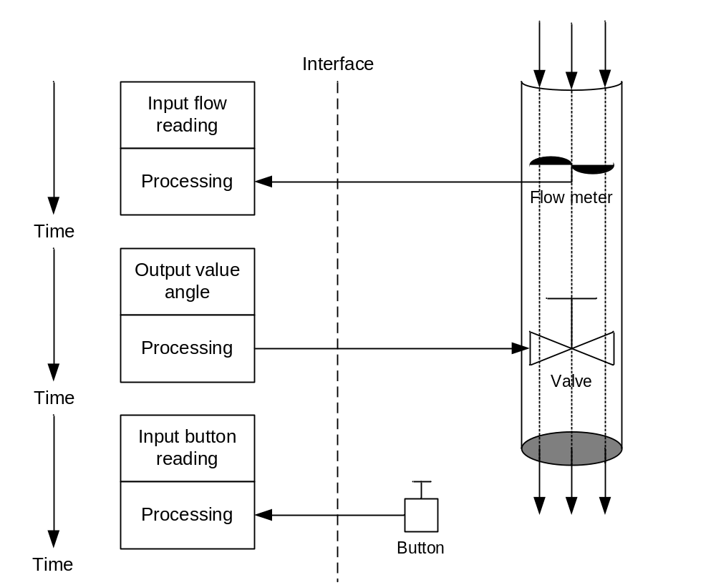
Figure 1: Experimental test set-up

The first challenge is the shared data between the input flow reading and the output value angle, which are both periodic processes. The second challenge is the sporadic process monitoring the button, and its control of the other processes. If we consider it an emergency-button then the sporadic process must be able to pre-empt the other processes.

This, all in all, calls for two mutexes to protect the data shared between the input flow process and output valve process and the input button process and the other processes respectively. Naturally this is only true if the data is more than a simple primitive, as it can then be assigned and read atomically, requiring no protection. We consider the flow values and the button data to be multiple primitives or complex data structures.

Priority-wise we define the valve to always function on the newest data, thereby making the input flow reading the most important. The periods are simply chosen, as is the deadlines and execution cost (highest priority = highest number).

Process | Priority | Type | Period/min. interval  (T) | Deadline (D) | Execution cost  (C)
Input button reading process | 3 | Sporadic | 50ms | 30ms | 20ms
Input flow reading process | 2 | Periodic | 500ms | 200ms | 35ms
Output valve angle process | 1 | Periodic | 500ms | 200ms | 70ms

We could consider the release jitter. This is defined by the scheduler, which in this platform is defined by the operating system; TS-Linux. Though the exact value is unknown it is safe to say that it will be many orders of magnitude smaller than the other factors in the system. Lets set it at e.g. 10us. Given that only around 2 - 14 possible scheduling occurrences can happen in a full period, the maximum total disturbance is about 140us, which can safely be considered negligible.

We need to consider the execution cost of the three processes. As there are potential blocking involved we have to factor this in, but for now we focus on the raw machine instruction execution cost. By analysing the machine code for the three process we can set up the following colour-coded diagram for the execution cost.

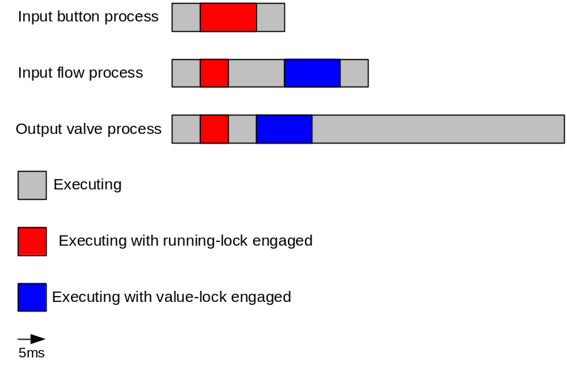

Based on this we can perform the response time analysis and determine if the system will always meet its deadlines.

Before we consider the mathematical solutions, we can do a graphical representation of the worst case without blocking, which is all processes being released simultaneous and the sporadic process continuously arriving at its minimum inter-arrival time. As the sporadic process is a button it is naturally not logical that it will arrive in this manor, yet this fact is irrelevant for this analysis.

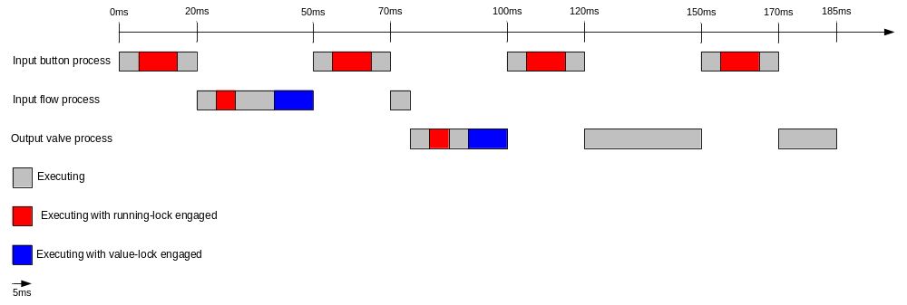

Process | Time from initiation until completion
Input button reading process | 20ms
Input flow reading process | 75ms
Output valve angle process | 185ms

Unfortunately this is not necessarily the real worst-case (at least it might not be), as there is potential blocking from the lower-priority processes, as may be seen below. An important note here is that this example considers no priority inheritance and no ceiling protocol what so ever – otherwise the example would not be feasible. Please also not that here the starting points are offset from each other, and that this actually improves the response time of the input flow process, even though it suffers blocking; this shows the potential power of offset, yet unfortunately this has to be used very judiciously, as it is a strongly NP-hard problem choosing optimal offsets, and if used with a sporadic process it is an impossibility.

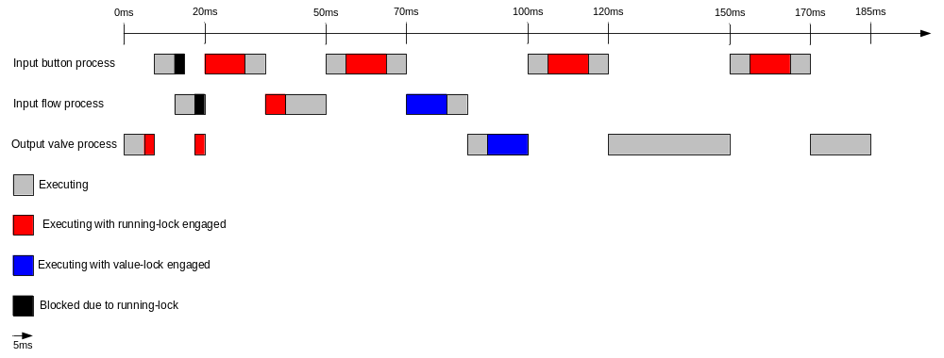

Process | Time from initiation until completion
Input button reading process | 27,5ms
Input flow reading process | 74,75ms
Output valve angle process | 185ms

Blocking causes priority inversion, allowing multiple lower priority processes to block a higher priority processes. As we can see this causes the highest priority process to be delayed considerably.

So, how do we make sure we take all these possible scheduling-times into consideration? There are potentially an infinite amount of scheduling paths. Luckily there are mathematical formulas to help us with this.

R_{i} = C_{i} + I_{i} + B_{i}

R_{i} is the response time for process i.
C_{i} is the execution cost of process i.
I_{i} is the interference imposed by higher priority processes on process i.
B_{i} is the blocking from lower priority processes suffered by process i.

I_{i} = sum_{j}(ceiling(R_{i}/T_{j})*C_{j})

B_{i} = max_{k}(usage(k,i)*C(k))

The blocking is for ICCP only, other protocols have different blocking calculations. The blocking equations can be simplified verbally to: “The cost of the single largest critical region in a lower priority process, which is also shared by process i”.The reason this is true, is because the immediate ceiling priority protocol (unlike the original ceiling priority protocol) always assign the highest priority of anyone using the critical section whenever there is contention about the access to the critical section. This means that is a higher priority process is blocked by a lower priority process, the lower priority process will be boosted to the highest priority, meaning there is no way for any other process, using the critical section, to gain execution time, and therefore multi-process blocking is impossible. This is only true when all processes are assigned different priorities or if no round-robin is employed. If this was not the case then the low-priority process with the lock might be scheduled out by another process with equal priority, which could then take another lock. If the processes all have different priorities this is not the case; when the low priority process is boosted to the higher priority it is only because the higher priority process has attempted to take the lock, and therefore this process is effectively blocked and the boosted process is then the only runnable process with that priority.

To manually calculate I_{i} requires a little more mathematics. This is due to the fact that R_{i} appear on both sides of the equation, and it contains a sum. We therefore have to do the calculations using a special principle.

The equation

W_{i}^{n+1} = C_{i} + B_{i} + sum_{j}(ceiling(W_{i}^{n} / T_{j})*C_{j})

can be repeated for n going from 0 towards infinity. The calculations must be stopped when two identical results are reached for two consecutive values of n. W⁰_{i} is calculated by simply setting the sum to 0. Naturally it is not possible for the highest priority process to suffer interference, so for that process R_{i} = C_{i} + B_{i}.

Based on these equations we can perform the calculations. We need to define a value of i for each of the processes, and here we can e.g. use the static process priority, as it is, and must be, unique to the process.

As the highest priority process share only one critical section with lower priority processes, and the maximum length of this critical section in the lower priority processes are 5ms, we can determine B₃ as 5ms. And naturally there cannot be any interference from other processes, as they are all lower priority.

R₃ = 20 (C₃) + 0 (I₃) + 5 (B₃) = 25ms.

For the second highest priority it is a little more complicated. The potential blocking is again the longest critical section in a lower priority process also used by this process. Here the value-lock is shared, and potential blocking is then 10ms. With this we can attempt to calculate the response time.

There is only one process with higher priority, so there is only one process to consider for interference.

W₂⁰ = C₂ + B₂ = 35 + 10 = 45ms

W₂¹ = C₂ + B₂ + ceiling(W₂⁰ / T₃) * C₃ = 35 + 10 + ceiling(45 / 50) * 20 = 35 + 10 + 1 * 20 = 65ms

W₂² = C₂ + B₂ + ceiling(W₂¹ / T₃) * C₃ = 35 + 10 + ceiling(65 / 50) * 20 = 35 + 10 + 2 * 20 = 85ms

W₂² = C₂ + B₂ + ceiling(W₂¹ / T₃) * C₃ = 35 + 10 + ceiling(85 / 50) * 20 = 35 + 10 + 2 * 20 = 85ms

Giving us

R₂ = 85ms

The lowest priority is similar in calculation, except the lowest priority cannot suffer blocking and it has two processes which may cause interference.

W₁⁰ = C₁ + B₁ = 70 + 0 = 70ms

W₁¹ = C₁ + B₁ + ceiling(W₁⁰ / T₃) * C₃ + ceiling(W₁⁰ / T₂) * C₂
= 70 + 0 + ceiling(70 / 50) * 20 + ceiling(70 / 500) * 35
= 70 + 0 + 2 * 20 + 1 * 35 = 145ms

W₁² = C₁ + B₁ + ceiling(W₁¹ / T₃) * C₃ + ceiling(W₁¹ / T₂) * C₂
= 70 + 0 + ceiling(145 / 50) * 20 + ceiling(145 / 500) * 35
= 70 + 0 + 3 * 20 + 1 * 35 = 165ms

W₁³ = C₁ + B₁ + ceiling(W₁² / T₃) * C₃ + ceiling(W₁² / T₂) * C₂
= 70 + 0 + ceiling(165 / 50) * 20 + ceiling(165 / 500) * 35
= 70 + 0 + 4 * 20 + 1 * 35 = 185ms

W₁⁴ = C₁ + B₁ + ceiling(W₁³ / T₃) * C₃ + ceiling(W₁³ / T₂) * C₂
= 70 + 0 + ceiling(185 / 50) * 20 + ceiling(185 / 500) * 35
= 70 + 0 + 4 * 20 + 1 * 35 = 185ms

Giving us

R₁ = 185ms

Now we can compare the result of the response time analysis to the deadlines previously defined

Process | Response time (R) | Deadline (D)
Input button reading process | 25ms | 30
Input flow reading process | 85ms | 200
Output valve angle process | 185ms | 200

From this we can see that all processes will meet their deadlines. In our example we have used rate monotonic priority assignment, but that is not a demand for the ICPP and the response time analysis to be valid. The rate monotonic priority assignment is simply guaranteed to be at least as schedulable as any other in pre-emptive fixed priority-based scheduling.

Implementation
To implement the above using out platform is relatively simple, and the below pseudo-code example will show this.

Input button reading process
class InputButtonReaderThread : public SporadicThread
{
public:
InputButtonReaderThread(Mutex& runningLock, RunningValues& runningValues)
: SporadicThread(3, 40000), mRunningLock(runningLock),
mRunningValues(runningValues)
{
// attach button interrupt to this->release method.
}
void sporadicWork()
{
mRunningLock.lock();
// update running values
mRunningLock.unlock();
}
private:
Mutex& mRunningLock;
RunningValues& mRunningValues ;
};

Input flow reading process
class InputFlowReaderThread : public PeriodicThread
{
public:
InputFlowReaderThread(Mutex& runningLock, Mutex& valueLock,
RunningValues& runningValues, FlowValues& flowValues)
: PeriodicThread(2, 500, 40000), mRunningLock(runningLock),
mValueLock(valueLock), mFlowValues(flowValues)
{ }
void periodicWork()
{
runningLock.lock();
// Evaluate whether to continue based on running values
runningLock.unlock();

// Read flow values from flow meter
mValueLock.lock();
// Update the flow values
mValueLock.unlock();
}
private:
Mutex& mRunningLock;
Mutex& mValueLock;
RunningValues& mRunningValues;
FlowValues& mFlowValues;
};

Output valve angle process
class OutputValveAngleThread : public PeriodicThread
{
public:
OutputValveAngleThread(Mutex& runningLock, Mutex& valueLock,
RunningValues& runningValues, FlowValues& flowValues)
: PeriodicThread(1, 500, 40000), mRunningLock(runningLock),
mValueLock(valueLock), mFlowValues(flowValues)
{ }
void periodicWork()
{
runningLock.lock();
// Evaluate whether to continue based on running values
runningLock.unlock();

mValueLock.lock();
// Access shared memory and read the flow values.
mValueLock.unlock();

// Update the valve angle based on the read flow values
}
private:
Mutex& mRunningLock;
Mutex& mValueLock;
RunningValues& mRunningValues;
FlowValues& mFlowValues;
};

Main
int main(int argc, char* argv[])
{
Mutex runningLock(3); // 3 is ceiling priority for running-lock
Mutex valueLock(2); // 2 is ceiling priority for value-lock
RunningValues runningValues;
FlowValues flowValues;

InputButtonReaderThread buttonReader(runningLock, runningValues);
InputFlowReaderThread flowReader(runningLock, valueLock ,
runningValues, flowValues);
OutputValveAngleThread valveAngle(runningLock, valueLock ,
runningValues, flowValues);

buttonReader.start();
flowReader.start();
valveAngle.start();

// Block “forever”
return 0;
}

As the current design do not include the parts of RT Java, which monitors whether the dead-lines are met, whether the pre-emption is performed and whether the immediate ceiling priority protocol is obeyed, it is not possible to directly determine whether the platform meets its requirements just by running this test. It is however possible to instrument the software with some diagnostics code to perform these tests.

This can be done by

1. Use the Clock to get the absolute time when the ...Work methods are entered and left and then compare the relative time between these values with the deadline for the process.
2. Log the absolute times when a process becomes runnable, blocked or delayed (requires some OS-support, yet much can be done by instrumenting the Mutex and Thread classes). Analysing this log will describe which processes are allowed to run when.
3. Monitor how often the sporadicWork is performed and thereby determining if the minimum interval has been violated.

